DEFORESTATION IN NIGERIA, A WIKIPEDIA PROJECT OF THE UNIVERSITY OF NIGERIA – THE JOURNEY SO FAR.

This project is a collaboration between Wikimedians in Southeast Nigeria, the Department of Geography and Institute of Climate Change Studies, Energy, and Environment, University of Nigeria, Nsukka (UNN). Wikimedians in Southeast Nigeria are made up of Wikimedians in UNN and Nnamdi Azikiwe University, Awka, (UNIZIK). The project is a six-month project supported by the Wikimedia Foundation with a grant. The project involved the training of the students of the Department and Institute to document information on Deforestation in Nigeria in Wikipedia based on existing literature and to support them on field trips to deforestation sites in Nigeria to capture pictures to support their documentation.
This project arose out of a 9-week training organized by the Wikimedia Foundation for their outstanding project organizers. The training was aimed to equip the participants with the skill to identify areas of information gap on Climate change and sustainability in Wikimedia that is relevance to their society and collaborating with experts in the field to close the gap. 30 Wikimedia event organizers were selected globally by the Wikimedia Foundation to participate in the training. 17 participants completed the training successfully and were asked to apply for grant to implement their learning.
The project, Deforestation in Nigeria officially took off at the University of Nigeria on May 22, 2023 with a courtesy call to the University Vice-chancellor, opening ceremony in which the project was declared open. The Project was welcomed with much excitement from the University of Nigeria Administration and the participants. This to some extent portrays the interest of universities and professional groups in partnering to contribute to open knowledge.
The theme of the project is “Deforestation in Nigeria”. It covered all knowledge issues related to deforestation in Nigeria. It includes topics such as gully erosion, forest reserves, use of fuel wood, wood trade in Nigeria etc. In the life of this project, there have been five days of physical training (three days budgeted for and two days unbudgeted for) four sessions of online training and three radio talks. All aimed at equipping the participants with the skill to contribute effectively to Wikimedia and creating awareness for the project.
Analysis of the pre-training questionnaire administered to participants at the beginning of the projects reveal the demography of the participants as follows:

Fig. 1. Age of participants
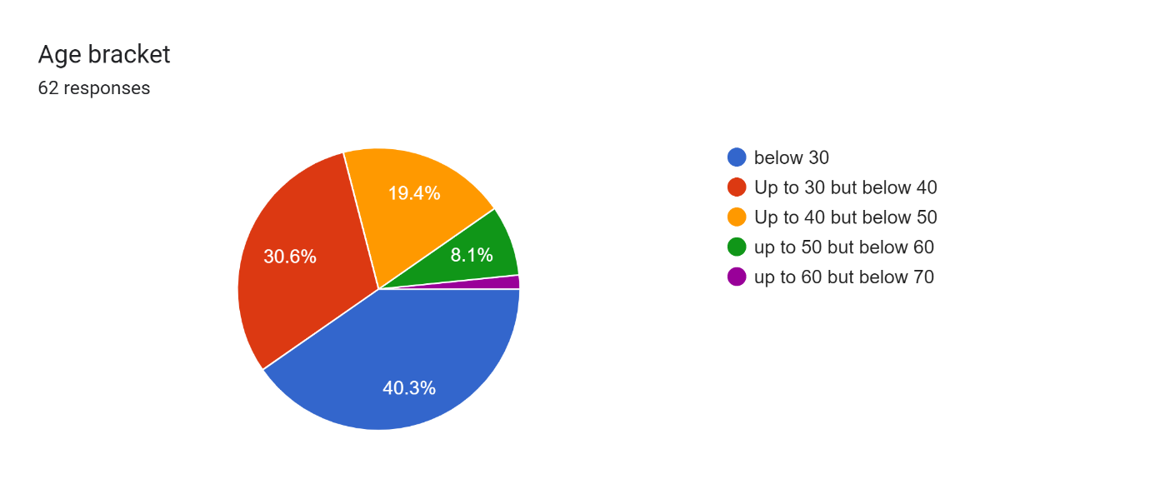
Responses on the age of the participants (Fig, 1) show that majority (40.3%) of the participants were below 30 years age bracket. This was followed by people up to 30 years but below 40 years (30.6%). The age group with the least number of participants is the group who are up to 50 years but less than 60 years. None of the participants is up to 60 years. This finding throws light on the category of people currently undergoing postgraduate studies in Nigeria, has digital skills and interested in contributing to Wikimedia. Though the participants were selected by their departments, possession of digital skills was one of the stipulated criteria for the selection.

Fig. 2. Participant’s affiliation
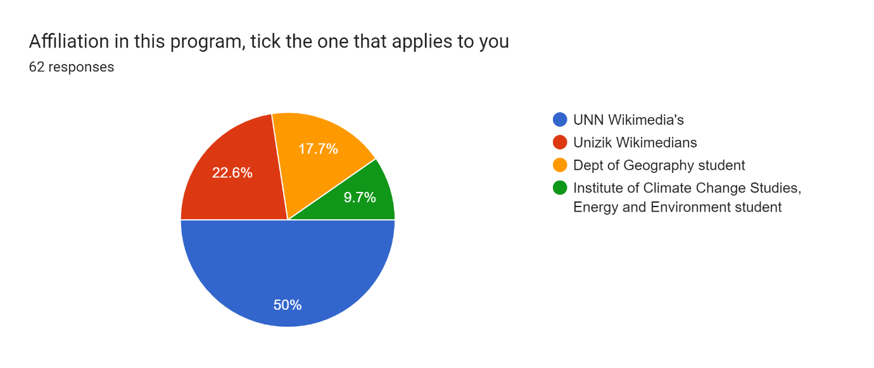
Fig 2 shows that majority (50%) of the participants are affiliated to UNN Wikimedians. UNN Wikimedian are Wikimedians in the University of Nigeria, Nsukka (UNN) The second largest group (22.6%) are affiliated to Unizik Wikimedians. Unizik Wikimedians are Wikimedian from Nnamdi Azikiwe University, Awka, Anambra State. Institute of Climate Change Studies, Energy and the Environment has the smallest number of participants (9.7%). It is not surprising that majority of the participants are affiliated to UNN Wikimedians because the project leader is a Staff of UNN and the project is domiciled at UNN.

Fig 3.
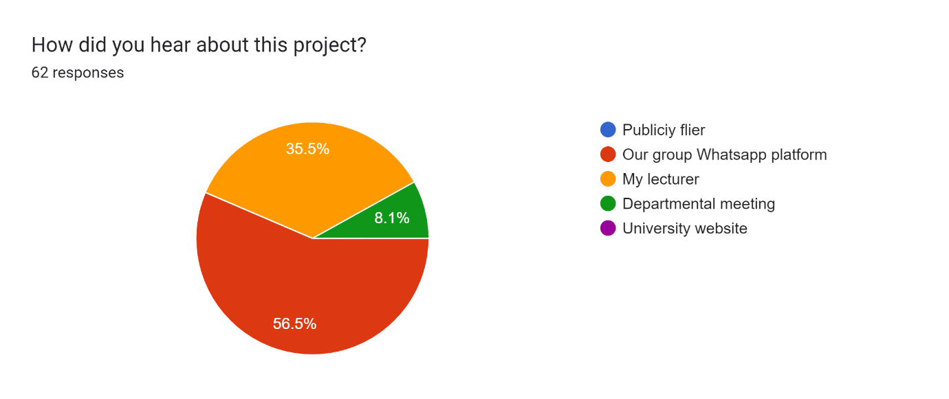

Responses on how the participants heard about the program show that majority (56.5%) of the participants heard about the program through their Wikimedia group WhatsApp platforms. 35% heard it through their lecturers. None of the participants heard about the program through publicity flier or University website. This finding is not surprising. Researches such as Udem, Aghoghovwia and Baro (2020) and Ahmad (2020) have proved that WhatsApp messaging among other Social Networking Sites (SNS) is used mostly by professional groups and students for communication.

Fig. 4.
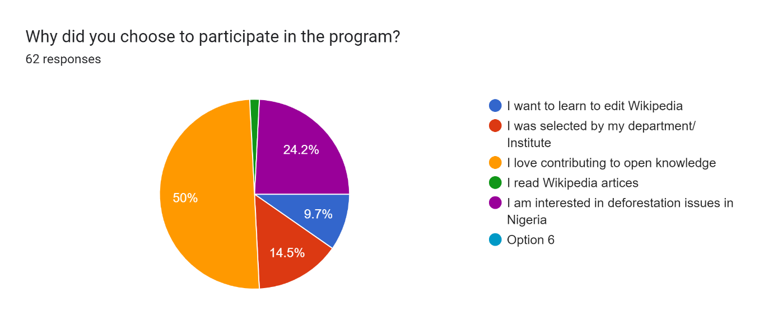
Responses on why the participants choose to participate in the program (Fig. 4) show that the majority of the participants (50%) love contributing to open knowledge. This was followed by participants who joined because they are interested in deforestation issues in Nigeria (24.2%). 9.6% joined the program because they want to learn to edit Wikipedia. This finding buttresses the point that academia attitude to Wikimedia articles is changing (Aibar, 2020)

Fig. 5.
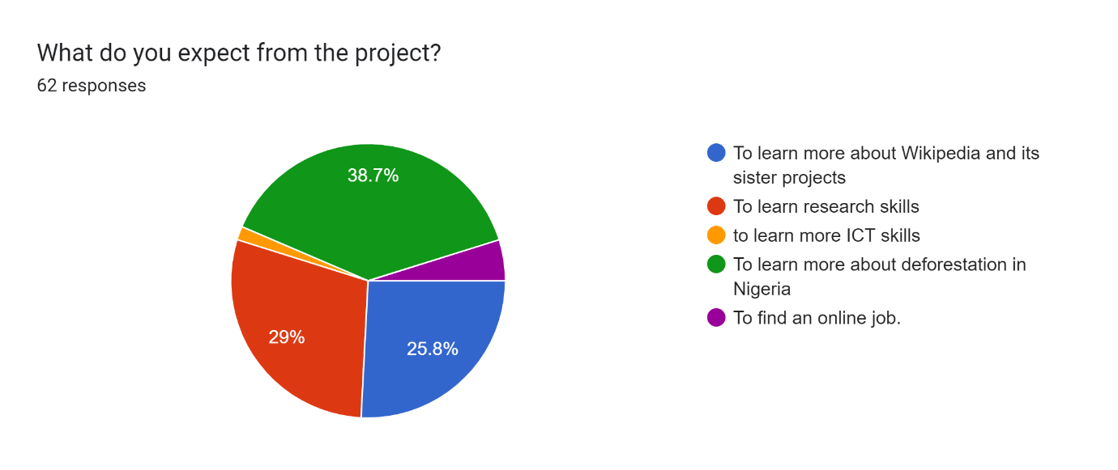
Responses on the expectation of the participants from the project (Fig. 5) show that majority of the participants 38.7% joined the program to learn more about deforestation in Nigeria, 29% joined to learn research skills while 25.8% joined the program to learn more about Wikipedia and its sister projects.

Fig 6.
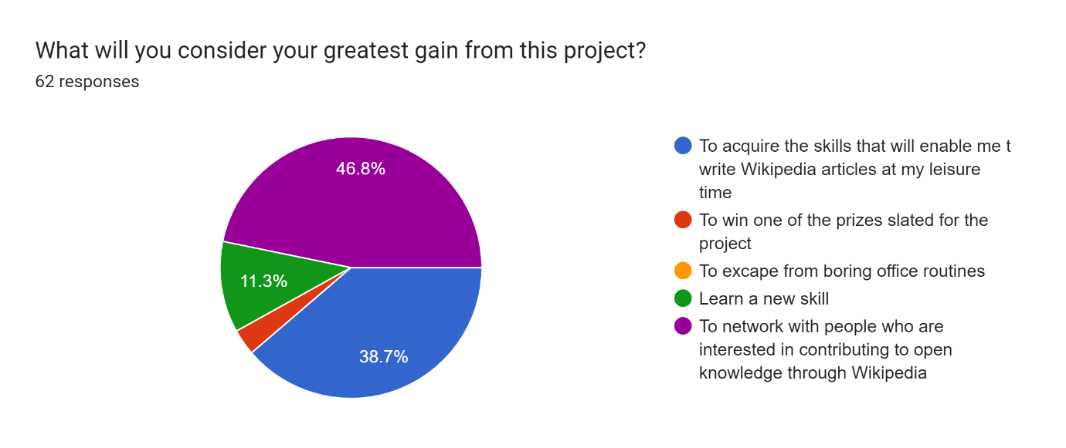
Responses on the question on what the greatest gain of the participants for joining the projects show that there are three things which the participants consider their greatest gain. Among the three mentioned things, to network with people who are interested in contributing to open knowledge through Wikipedia scored 46.8%. To acquire the skill that will enable me to write Wikipedia articles at my leisure time came second with 38.7% and lastly to learn a new skill with 11.3%. These responses buttress the interest of the participants in the Wikimedia project.

The project has entered its fifth week. At the end of the life of the project in October, 2023, another survey will be administered to the participants to find out if their expected goals for joining the project were achieved. Though the project is still ongoing, the organizer and participants have had lots of learning from it.
Learnings from the project.
Many people do not have knowledge of the paucity of information on African countries in online encyclopedia such as Wikipedia. This project helped to bring this to the attention of Nigerian professionals in the field of Climate Change and the environment in the University of Nigeria.
Many people do not know how Wikipedia articles are created. Many of the participant received for the first-time, information on how Wikipedia articles are made. Interview with some of the participants show that the opinions they hold on Wikipedia articles are based on what they heard other people say.
Though new participants may prefer to create new articles of their choices, it is important that they are discouraged and rather encouraged to contribute to existing articles. This is to forestall the situation where articles in the stub category fill the projects dashboard which may attract the attention of Wikipedia administrators with its destabilizing effects on new editors.
Projects of these magnitude and duration need regular physical meeting of participants to ensure that individual contribution conform to the stipulated guideline of contributing to Wikimedia and also to ensure that participants interests are retained. Allowing individual to work on their own individually for a long time without supervision has not proved successful in this project. Moreover, our experiences have shown that online synchronous meetings are not effective for online workshops such as contributing to Wikipedia. While many participants key into our online workshops, not many contribute to discussions.
The project brough about a change in perception of some of the participants who were University lecturers on the use of Wikipedia in academic research. Through participation in this project, some lecturer participants noticed that Wikipedia articles were based on information gotten from published reliable sources.
Hiring computers to teach people how to contribute content to Wikimedia does not serve the intended purpose of increasing the number of Wikipedia editors because at the end of the training, when the hired computers must have been returned, the newly trained editors have no computers to practice what they learned.

Some of the pictures taken at the workshop can be viewed at our meta page at: https://meta.wikimedia.org/wiki/Deforestation_in_Nigeria/Gallery

References
Udem, O.K; Aghoghovwia, D.U and Baro E.E. (2020). WhatsApp groups: Channel for sharing information among LIS professionals in Nigeria. The Electronic Journal. 38:4, 805-820. https://www.researchgate.net/profile/Obiora-Udem/publication/344158785_WhatsApp_groups_channel_for_sharing_information_among_LIS_professionals_in_Nigeria/links/61519da1522ef665fb620452/WhatsApp-groups-channel-for-sharing-information-among-LIS-professionals-in-Nigeria.pdf

Aibar, E. (2020). Wikipedia at University: What Faculty think and do about it. In Valentine Galloe Corrado Petrucco,Wikipedia in academia. Padova, Padova University Press. 17 -23. https://www.research.unipd.it/bitstream/11577/3396214/1/Wikipedia%20in%20Academia.pdf#page=17

